Act of Thanksgiving Please stand.
Psalm 100
Cry out with joy to the Lord, all the earth.
Serve the LORD with gladness;
Come before him, singing for joy.
Know that he, the Lord, is God.
He made us, we belong to him.
we are his people, the sheep of his flock.
Go within his gates, giving thanks.
Enter his courts with songs of praise.
Give thanks to him, bless his name.
Indeed, how good indeed is the Lord,
eternal his merciful love.
He is faithful from age to age.

Concluding Rites
Collection and Announcements Please sit.
Invitation to Pray for Vocations to the Priesthood Please stand.
Loving Father, you sent your Son
so that all might come to know the truth and be saved.
With the outpouring of the Holy Spirit,
you continue his work through the Church.
Your Son reminded his disciples that the harvest
was indeed plentiful but the laborers few.
Following his instructions, we beg you
to call many to ordained priesthood.
Grant them the grace to hear you
and to respond wholeheartedly.
May Mary Immaculate the mother of your Son,
and the patroness of our diocese, intercede for us.
We ask this through Christ our Lord. Amen
Blessing
Sign of Peace

Cover image created by Rev. Antony Alexander Maria Doss, HGN
for the Roman Catholic Diocese of Portland ©2019. All rights reserved.

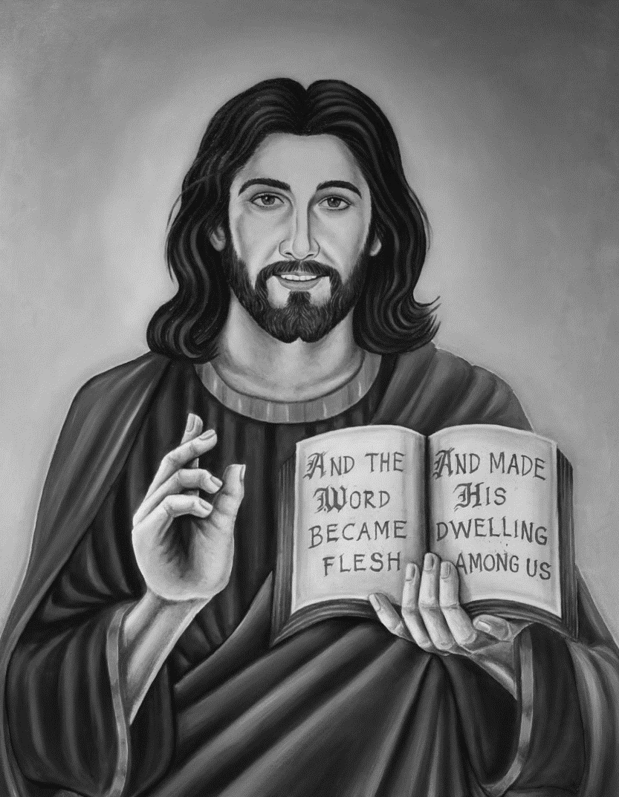
Roman Catholic Diocese of Portland

Sunday Celebration
in the Absence of a Priest
Liturgy of the Word with Holy Communion

When the absence of a priest does not allow for the fullness of the Eucharist in the Mass, a deacon or diocesan-appointed lay person
leads the Catholic community gathered to celebrate the Lord’s Day.
We fulfill our Sunday obligation by sharing Christ present in the
Liturgy of the Word, through the sharing of holy communion,
and among us as the People of God gathered in Jesus’ name.
July 2020

Please genuflect or bow to reverence the altar or tabernacle
as you usually do when entering or leaving the church
This liturgy has no formal entrance or concluding procession of ministers.

Introductory Rites
Introduction

Sign of the Cross Please stand.
Leader: †In the name of the Father, and of the Son,
and of the Holy Spirit.
All: Amen.

Greeting
Leader: Grace and peace to you from God our Father
and from the Lord Jesus Christ. Blessed be God for ever.
All: Blessed be God for ever.

Opening Prayer
Leader: Let us pray. …
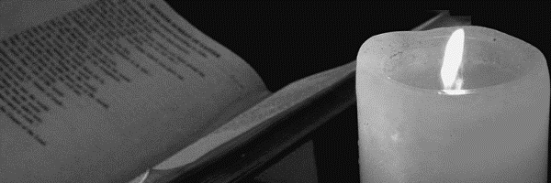
All: Amen.

Liturgy of the Word
First Reading Please sit.
Responsorial Psalm
Second Reading
Gospel Acclamation Please stand.
Gospel
Homily (Deacon) or Reflection (Lay Person) Please sit.
Period of Silence
Profession of Faith Please stand.
Nicene Creed
He ascended into heaven
and is seated at the right hand
of the Father.
He will come again in glory
to judge the living and the dead
and his kingdom will have no end.
I believe in the Holy Spirit,
the Lord, the giver of life,
who proceeds from
the Father and the Son,
who with the Father and the Son
is adored and glorified,
who has spoken
through the prophets.
I believe in one, holy,
catholic and apostolic Church.
I confess one Baptism for
the forgiveness of sins and
I look forward to
the resurrection of the dead
and the life of the world to come. Amen.

I believe in one God,
the Father almighty,
maker of heaven and earth,
of all things visible and invisible.
I believe in one Lord Jesus Christ,
the Only Begotten Son of God,
born of the Father before all ages,
God from God, light from Light,
true God from true God,
begotten, not made,
consubstantial with the Father;
through him all things were made.
For us men and for our salvation
he came down from heaven,
and by the Holy Spirt was
incarnate of the Virgin Mary,
and became man.
For our sake he was crucified
under Pontius Pilate,
he suffered death and was buried,
and rose again on the third day
in accordance with the Scriptures.

Prayer of the Faithful

Communion Rite
Lord’s Prayer Please stand.
Please kneel as the consecrated hosts are brought to the altar.
Invitation to Communion

Leader: Behold the Lamb of God,
behold him who takes away the sins of the world.
Blessed are those called to the supper of the Lamb.
All: Lord, I am not worthy that you should
enter under my roof,
but only say the word and my soul shall be healed.

Communion Those who come forward to share in the Body of Christ,
be mindful the U.S. Bishops instruct us to receive holy communion standing.

